EBN 111 – Summary

Chapter 1

Charge and Current
- Charge is an electrical property of the atomic particles of which matter consists – measured in coulombs
  - Charge on 1 electron: -1,602 x 10⁻¹⁹C
  - 1C = 6.24 x 10¹⁸ electrons
  - Charge cannot be created/ destroyed, only transformed
- Current – rate of change of charge (Ampere)
  - $i=\frac{q}{t}$
  - However, current is not always constant, therefore $i=\frac{dq}{dt}$
    - Example 1 – Determine the current if $q\left(t\right)=8t^{2}+4t-2$ at t=3
$$i=\frac{dq}{dt}$$
$$i=\frac{d}{dt}\left(8t^{2}+4t-2\right)$$
$$i=16t+4$$
$$i=16×3+4$$
$$i=52A$$

    - Example 2 - Determine the current if $q\left(t\right)=10sin⁡(120πt)$ at t=0.5
$$i=\frac{dq}{dt}$$
$$i=\frac{d}{dt}10sin⁡(120πt)$$
$$i=10\cos\left(120πt\right)×120π$$
$$i= 1200πA$$

  - Similarly $Q=\int_{t_{0}}^{t}{i dt}$
    - Example 1 – Find Q if $i\left(t\right)=20cos⁡(10t+\frac{π}{6})$ ) and between t(0) and t(1)
$$Q=\int_{t_{0}}^{t}{i dt}$$
$$Q=\int_{t_{0}}^{t}{20cos⁡(10t+\frac{π}{6}) dt}$$
$$Q={\left[-200sin⁡(10t+\frac{π}{6})\right]}_{0}^{1}$$
$$Q=278,13C$$

- Direct current – current remains constant
- Alternating current – current that varies sinusoidally with time

Voltage
- Emf/potential difference/ voltage – the energy required to move charge through a conductor
- $v=\frac{w}{q}$
- If v is not constant then $v=\frac{dw}{dq}$
- Voltage can be positive or negative depending on how it is represented
  - As current moves through an element, the voltage drops or is used up
  - Thus the voltage “up current” will be higher (or lower if it is a cell) than that below the element
  - Thus if voltage is represented from above to below the element then it is positive and if it is represented from below to above then it is positive
- Voltage can also be represented positively or negatively according to whether it is supplied or used up buy the element

Power and Energy
- Power – the rate at which energy is expended (Watts)
  - $p=\frac{dw}{dt}=vi$
  - Power calculated using p=vi – instantaneous power
  - Power is either positive or negative
    - Positive when
      - Energy is expended or used (as in a resistor)
      - Current enters the positive terminal of the element
    - Negative when
      - Energy is supplied (as in a cell)
      - Current enters the negative terminal of the element
  - Energy must be conserved, therefore total power of a system must equal zero
- Energy – the capacity to do work
  - Measured in joules or watthours
  - $w=\int{v dq}$

Circuit elements
- Active elements – elements that generate energy
  - Ideal independent source – supplies voltage or current of a specific quantity no matter what the rest of the circuit looks like
+
-
    - Symbol - voltage current
  - Ideal dependant source – supplies energy in quantities controlled by another element
    - Types
      - Voltage controlled voltage source (VCVS)
      - Voltage controlled current source (VCCS)
      - Current controlled voltage source (CCVS)
      - Current controlled current source (CCCS)
    - Symbol – same as independent with a diamond instead of a circle
- Passive – elements that is not capable of generating energy

Chapter 2

Ohm’s Law
- Used to calculate resistance – the force that resists the flow of electric charge
- Can be calculated using:
  - $R=ρ\frac{l}{A}$
    - P – resistivity of the material
    - L – length of the resistor
    - A – cross-sectional area of the material
  - $R=\frac{v}{i}$
  - R – measured in Ohms (Ω)
  - R is always positive
- Power in resistors
  - $P=i^{2}R$
  - $P=\frac{v^{2}}{R}$
  - Power in a resistor is always positive
- Law only applies to linear resistors (where v α i)
- Open circuit – circuit with an element with resistance approaching infinity
- Short circuit – circuit with resistance approaching zero
- Conductance – the ability of an element to conduct electric current
  - Measured in mhos or Siemens (S)
  - Is the inversion of resistance - $G=\frac{1}{R}$

Nodes, Branches and Loops
- Branch – a single element such as a voltage source or a resistor
- Node – a point of connection between two or more branches
  - Two elements are in series if they are connected by a single node
  - Two elements are in parallel if they are connected to the same two nodes
- Loop – any closed path in a circuit
  - Independent loops
    - Loop cannot be broken down into smaller loops
    - Contains an element not found on other independent loops
  - Calculate numbers using – $b=l+n-1$
    - Where l represents independent loops

Kirchhoff’s Laws
- Current law – the sum of all currents entering and leaving a node must be zero
  - Write down the current value for all known branches around the node
  - Make each of these positive or negative according to whether the current is entering or leaving the node through the branch
  - Add together equalling 0
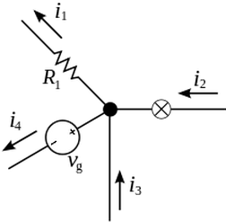
Example:

${-i}_{1}+i_{2}+i_{3}-i_{4}=0$

- Voltage Law – the sum of all voltages around a closed loop is zero
  - Start from any point and move clockwise
  - If current enters at the positive, add, if enters at negative, subtract
  - Add together, equalling zero
Example:
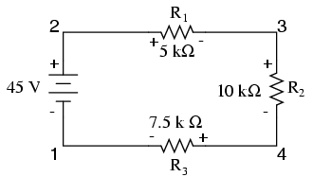
$R_{1}+R_{2}-R_{3}-C_{4}=0$
$$5×{10}^{3}i+10×{10}^{3}i-7,5×{10}^{3}i-45=0$$
$$7,5×{10}^{3}i=45$$

$$i=166,7A$$Series resistors and voltage division
- Resistors in series carry the same current
  - $∴i=\frac{v}{R_{eq}}$
  - $R_{eq}=R_{1}+R_{2}+R_{3}$
- Voltage division in series
  - $v_{n}=\frac{R_{n}}{R_{eq}}.v$

Parallel resistors and current division
- Resistors have the same voltage as the whole parallel system
  - $\frac{1}{R_{eq}}=\frac{1}{R_{1}}+\frac{1}{R_{2}}+\frac{1}{R_{3}}$
- Current division
  - If there are only 2 resistors
    - $i_{1}=i\frac{R_{2}}{R_{1}+R_{2}}$
  - If there are more than 2 resistors
    - $G=\frac{1}{R}$
    - $∴G_{eq}=G_{1}+G_{2}{+G}_{3}$
    - $∴i_{n}=i\frac{G_{n}}{G_{eq}}$
      - Convert all resistances into conductance
      - Find total G
      - Sub into formula

Wye-Delta Transformations
- Often is a more complex circuit, there are no obvious parallel and series resistors, however this can be changed to make it easier
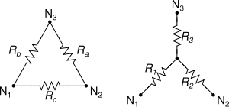
- Circuits in a delta form can be converted to wye form and visa-versa

- Balanced resistors – all resistors have the same ohm value
  - $R_{a}=R_{b}{=R}_{c}=R_{∆}$
  - $R_{1}=R_{2}{=R}_{3}=R_{y}$
  - $R_{∆}=3R_{y}$
Example:
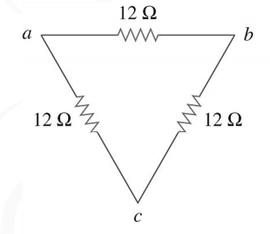
$R_{∆}=3R_{y}$
$$R_{∆}=12Ω$$
$$∴R_{y}=4Ω$$

- Wye to delta
  - $R_{a}=\frac{R_{1}R_{2}+R_{1}R_{3}+R_{3}R_{2}}{R_{1}}$
  - $R_{a}=\frac{all the products of possible 2 R_{n} values}{R_{n} value opposite}$
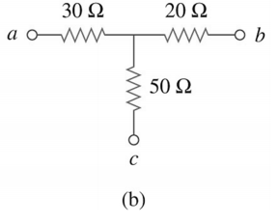
Example:
$$R_{a}=\frac{R_{1}R_{2}+R_{1}R_{3}+R_{3}R_{2}}{R_{1}}$$
$$R_{a}=\frac{30.20+20.50+30.50}{30}$$
$$R_{a}=103,33Ω$$
$$R_{b}=155Ω$$
$$R_{c}=62Ω$$

- Delta to wye
  - $R_{1}=\frac{R_{b}R_{c}}{R_{a}+R_{b}+R_{c}}$
  - $R_{a}=\frac{Product of adjacent resistors}{sum of all resistors in delta }$
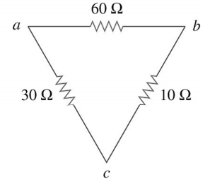
Example:
$$R_{1}=\frac{R_{b}R_{c}}{R_{a}+R_{b}+R_{c}}$$
$$R_{1}=\frac{30.60}{30+60+10}$$
$$R_{1}=18Ω$$
$$R_{2}=6Ω$$
$$R_{3}=3Ω$$

Chapter 3

Nodal Analysis
- Provides us with node voltages, using Kirchhoff’s current law
- Reduces the number of equations required to solve a circuit
- Steps
  - Select a node as the reference node (ground) – this node will have 0V as its potential difference
  - Assign voltages, V₁,V₂ etc. to each critical node (nodes with more than two branches)
  - Apply KCL to each of these named nodes – use ohms law to express the branch currents in terms of node voltages
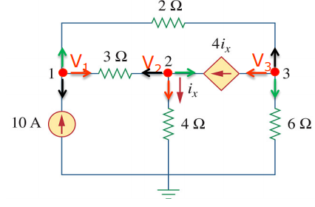
  - Solve the simultaneous equations (this case used Cramer’s rule)
Example: Find the node voltages

V1: $0=\frac{V_{1}-V_{2}}{3}-i+\frac{V_{1}-V_{3}}{2}$
$0=\frac{V_{1}-V_{2}}{3}-10+\frac{V_{1}-V_{3}}{2}$
$0=2V_{1}-{2V}_{2}-60+{3V}_{1}-{3V}_{3}$
$$60=5V_{1}-2V_{2}-{3V}_{3}$$

V3: $0=\frac{V_{3}-0}{6}+4i+\frac{V_{3}-V_{1}}{2}$
$$0=\frac{V_{3}-V_{1}}{2}+4i+\frac{V_{3}}{6}$$
$0={6V}_{3}-{6V}_{1 }$+12$V_{2}$+2$V_{3}$
$$0={-{3V}_{1 }+6V_{2}+4V}_{3}$$

$$\left[\begin{matrix}5 & -2 & -3 \\ -4 & -5 & 0 \\ -3 & 6 & 4\end{matrix}\right]\left[\begin{matrix}V_{1} \\ V_{2} \\ V_{3}\end{matrix}\right]=\left[\begin{matrix}60 \\ 0 \\ 0\end{matrix}\right]$$
$$\text{∆=}\left(\text{5.-5.4}\right)\text{+}\left(\text{-4.6.-3}\right)\text{+}\left(\text{-3.-2.0}\right)\text{-}\left(\text{-3.-5.-3}\right)\text{- }\left(\text{0.6.5}\right)\text{-}\left(\text{4.-2.-4}\right)$$
$$∆=-100+72+0+45-0-32$$
$$∆=-15$$

$$V_{2}=\frac{∆_{2}}{∆}$$
$$V_{2}=\frac{960}{-15}$$
$$V_{2}=-64V$$

V2: $0=\frac{V_{2}-V_{1}}{3}-i+\frac{V_{2}-0}{4}$
$0=\frac{V_{2}-V_{1}}{3}-4i+\frac{V_{2}}{4}$
$0=-4V_{1}+{4V}_{2}-12.4.\frac{V_{2}}{4}+{3V}_{2}$
$0=-4V_{1}+{4V}_{2}-12.4.\frac{V_{2}}{4}+{3V}_{2}$
$$0=-4V_{1}-{5V}_{2}$$

$$V_{1}=\frac{∆_{1}}{∆}$$
$$∆_{1}=\left[\begin{matrix}60 & -2 & -3 \\ 0 & -5 & 0 \\ 0 & 6 & 4\end{matrix}\right]$$
$$∆_{1}\text{=}\left(\text{60.-5.4}\right)\text{+}\left(\text{0.6.-3}\right)\text{+}\left(\text{0.-2.0}\right)\text{-}\left(\text{-3.-5.0}\right)\text{- }\left(\text{0.6.60}\right)\text{-}\left(\text{4.-2.0}\right)$$
$$∆_{1}=-1200$$
$$V_{1}=\frac{-1200}{-15}$$
$$V_{1}=80V$$

$$V_{3}=\frac{∆_{3}}{∆}$$
$$V_{3}=\frac{-2340}{-15}$$
$$V_{3}=156V$$

Supernodes
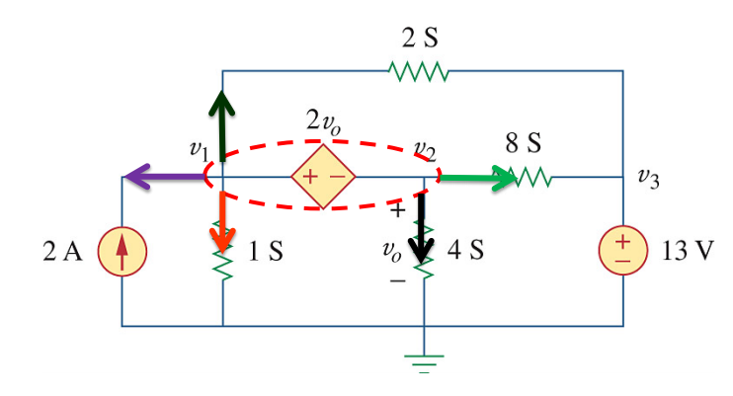
- The enclosed voltage source connected between any two non-reference nodes and any elements connected in parallel with it

- This is useful as it reduces the number of nodes and simplifies the problem
- Also creates a new equation: $v_{1}-v_{2}=2v_{0}$ (voltage across the supernode)
  - This is easier to work with then most other simultaneous equations

Mesh Analysis
- Mesh – loop that does not contain any other loops
- Mesh analysis – only applies to planar circuits
  - Planar circuit – can be drawn without any branches crossing
  - Nonplanar circuit – cannot be drawn without branches crossing
- Applies Kirchhoff’s voltage law to find mesh currents
- Steps
  - Assign mesh currents i₁, i₂,…i_{n} to each of the meshes – draw them as a current flowing clockwise through each mesh
  - Apply KVL to each of the meshes using Ohms law to express the voltages in terms of currents
    - If the branch is only present in one mesh then the current value will just be i₁, or whatever the mesh number is
    - If the branch is present in two meshes then the current is expressed as: i₁-i₂, where i₁ is the mesh that you are currently working with and i₂ is the other mesh
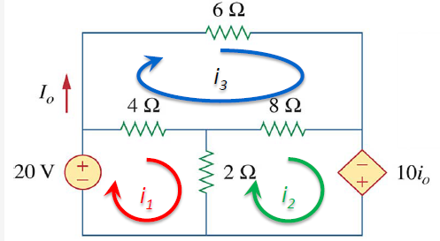
  - Solve the equations simultaneously
Example:

$$i_{0}=i_{3}$$
$${10i}_{0}=10i_{3}$$

$$i_{1}:0=-20+4\left(i_{1}-i_{3}\right)+2\left(i_{1}-i_{2}\right)$$
$$0=6i_{1}-4i_{3}-2i_{2}-20$$
$$i_{1}=\frac{4}{6}i_{3}+\frac{2}{6}i_{2}+\frac{20}{6}$$
$$i_{1}=\frac{4}{6}i_{3}+\frac{2}{6}\left(\frac{58}{28}i_{3}+\frac{20}{28}\right)+\frac{20}{6}$$
$$i_{1}=\frac{19}{14}i_{3}+\frac{25}{7}$$
$$i_{1}=\frac{19}{14}(-5)+\frac{25}{7}$$
$$i_{1}=-3,21A$$

$$i_{3}:0=6i_{3}+4\left(i_{3}-i_{1}\right)+8\left(i_{3}-i_{2}\right)$$
$$0=-4i_{1}+18i_{3}-8i_{2}$$
$$0=-4\left(\frac{19}{14}i_{3}+\frac{25}{7}\right)+18i_{3}-8\left(\frac{58}{28}i_{3}+\frac{20}{28}\right)$$
$$0=-4i_{3}-20$$
$$i_{3}=-5A$$
$$i_{2}:0=-10i_{3}+2\left(i_{2}-i_{1}\right)+8\left(i_{2}-i_{3}\right)$$
$$0=-2i_{1}-18i_{3}+10i_{2}$$
$$0=-2\left(\frac{4}{6}i_{3}+\frac{2}{6}i_{2}+\frac{20}{6}\right)-18i_{3}+10i_{2}$$
$$0=-\frac{4}{3}i_{3}-\frac{2}{3}i_{2}-\frac{20}{3}-18i_{3}+10i_{2}$$
$$0=\frac{28}{3}i_{2}-\frac{58}{3}i_{3}-\frac{20}{3}$$
$$i_{2}=\frac{58}{28}i_{3}+\frac{20}{28}$$
$$i_{2}=\frac{58}{28}(-5)+\frac{20}{28}$$
$$i_{2}=-9,64A$$

$$i_{0}=i_{3}$$
$$i_{0}=-5A$$

Supermeshes
- Supermesh – two meshes have a current source with or without other elements in series, in common
- Steps for super meshes
  - Assign the currents as normal for mesh analysis
  - Then combine the two meshes with the common source into one current
  - Then derive two equations from this supermesh
    - $i_{1}-i_{2}=current flowing through the source$
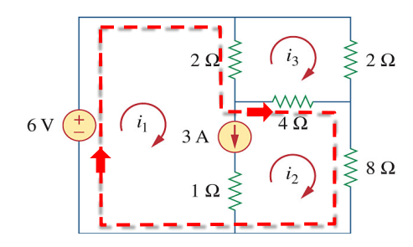
    - The general mesh analysis equation is terms of $i_{1}$ and $i_{2}$ for the large current
$$i_{1}-i_{2}=3A$$

$$0={2(i}_{1}-i_{3})+4(i_{2}-i_{3})+8i_{2}-6$$
$$6=2i_{1}+12i_{2}-6i_{3}$$

$$0=2\left(i_{3}-i_{1}\right)+2i_{3}+4\left(i_{3}-i_{2}\right)$$
$$0=-2i_{1}-4i_{2}+8i_{3}$$

$$\left[\begin{matrix}1 & -1 & 0 \\ 2 & 12 & -6 \\ -2 & -4 & 8\end{matrix}\right]\left[\begin{matrix}i_{1} \\ i_{2} \\ i_{3}\end{matrix}\right]=\left[\begin{matrix}3 \\ 6 \\ 0\end{matrix}\right]$$

$i_{1}=3,47A$
$$i_{2}=0,47A$$
$$i_{3}=1,11A$$

Nodal Analysis by Inspection
- Only can be used if all sources are independent current sources
- Use the equation:
$$\left[\begin{matrix}G_{1}{+G}_{2} & {-G}_{2} \\ -G_{2} & G_{2}{+G}_{3}\end{matrix}\right]\left[\begin{matrix}v_{1} \\ v_{2}\end{matrix}\right]=\left[\begin{matrix}i_{1}-i_{2} \\ i_{2}\end{matrix}\right]$$
  - Where the diagonal elements from the top left to the bottom right are the sum off all the conductances branching off the node
  - The other elements in the matrix are the value of the conductance directly between the two nodes
  - The current values represent the current entering (+) and exiting (-) the node – onlt applies to branches with current sources on them
- Equation can also look like:
$$\left[\begin{matrix}G_{11} & G_{21} \\ G_{12} & G_{22}\end{matrix}\right]\left[\begin{matrix}v_{1} \\ v_{2}\end{matrix}\right]=\left[\begin{matrix}i_{in}-i_{out} \\ i_{in}-i_{out}\end{matrix}\right]$$
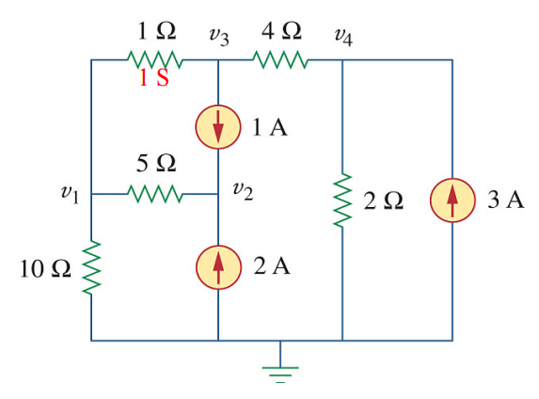
Example:
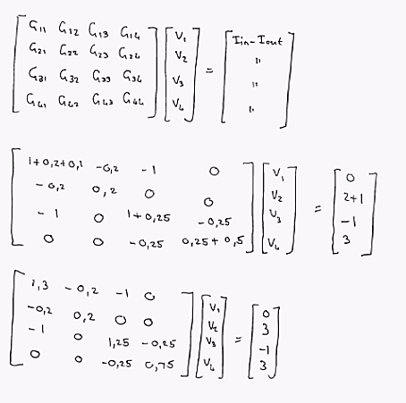

Mesh Analysis by inspection
- Only can be used with all sources as independent voltage sources
- Use the equation:
$$\left[\begin{matrix}R_{1}{+R}_{2} & {-R}_{2} \\ -R_{2} & R_{2}{+R}_{3}\end{matrix}\right]\left[\begin{matrix}i_{1} \\ i_{2}\end{matrix}\right]=\left[\begin{matrix}v_{1} \\ {-v}_{2}\end{matrix}\right]$$
  - Where the diagonal elements from the top left to the bottom right are the sum off all the resistances in the loop
  - The other elements in the matrix are the value of the resistances common between the two loops
  - Voltages represent the sum of all the voltage increases due to voltage sources within the loop
    - If current enters at – then sign is +
    - Enters at + then sign is –
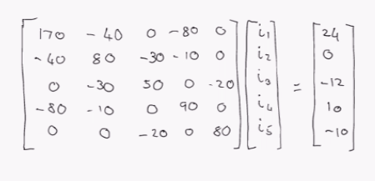
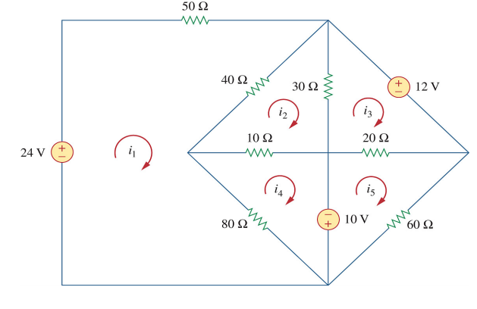
Example:

Nodal vs Mesh Analysis
- If the question specifies then follow it, if not then look at the following factors
  - Weigh up whether there are fewer nodes or meshes and then chose the one with the least
  - If there are more parallel elements – use nodal
  - More series – use mesh

Transistors
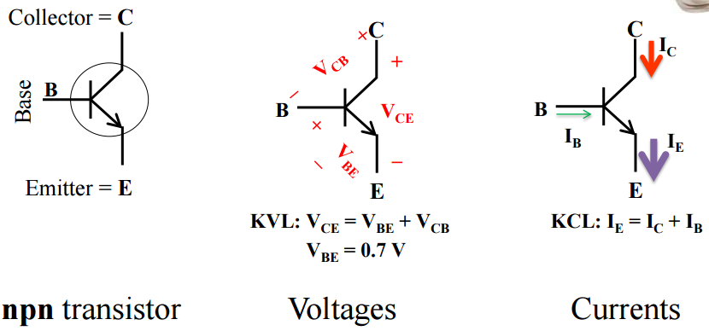
- Work with a BJT (Bipolar Junction Transistor) - most often made of layered materials (npn)

- Working with currents (mesh analysis)
  - Current I_{c} is increased by the current I_{B}, like a valve
  - $I_{C}=βI_{B}$ – where β is the common emitter gain (value of 50-100 usually)
  - $I_{C}=αI_{E}$ – where α is the common base current gain (value: 0.98-0.99)
  - $∴β=\frac{α}{1-α}$
  - Only really use the β value in practise
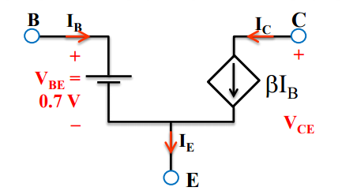
- Working with voltages (node analysis)
  - First redraw the circuit so that it is in the equivalent network model
  - Use KVL to calculate the values

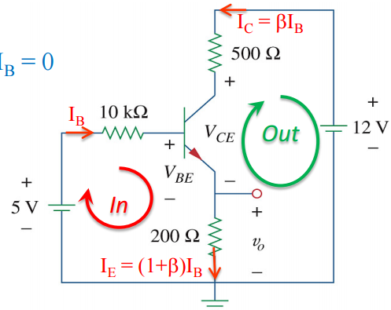
Example with Mesh analysis:
$$0=I_{b}\left(10000\right)+V_{BE}+\left(1+β\right)I_{b}\left(200\right)-5$$
$$0=I_{b}\left(10000\right)+0,7+\left(101\right)I_{b}\left(200\right)-5$$
$$I_{b}=0,14mA$$

$$0=-500{βI}_{b}+12-200\left(1+β\right)I_{b}-V_{CE}$$
$$0=-50000.I_{b}+12-20200\left(I_{b}\right)-V_{CE}$$
$$V_{CE}=2V$$

$$V_{o}=200(1+β)I_{b}$$
$$V_{o}=2,87$$

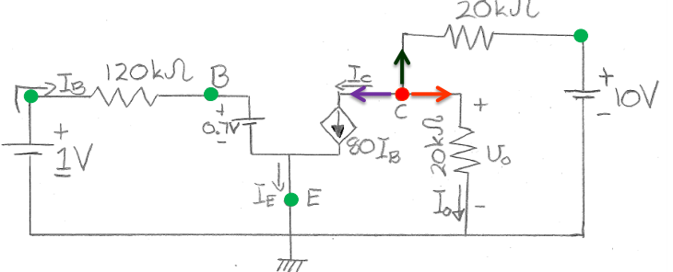
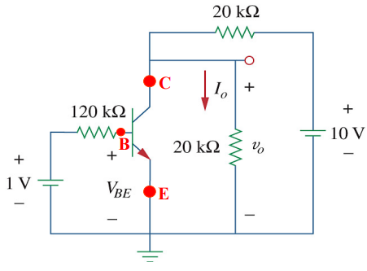
Example with Nodal analysis:
$$I_{B}=\frac{1V-0,7V}{120000}=2,5μA$$
$$I_{C}: 0={80I}_{B}+\frac{V_{C}-10}{20000}+\frac{V_{C}}{20000}$$
$$0=160000\left(2,5×10^{-6}\right)+2V_{C}-10$$
$$V_{C}=3V=V_{o}$$
$$I_{o}=\frac{V_{o}}{20000}=0,15mA$$

Chapter 4

Linearity
- A circuit in which the output is directly proportional to the input
  - The voltages and currents across the linear circuit will remain at a constant ratio
- Properties of linearity
  - Scaling – $v=iR→kv=kiR$
  - Additivity - $v=\left(i_{2}+i_{1}\right)R=v_{2}+v_{1}$
- Calculating values using linearity
  - Assume the final outcome (what you are calculating) to be 1 units or whatever is requested in value
  - Work backwards through the circuit using KVL and KCL for the assumed value until you reach a component with a fixed value
  - Find the ratio between the assumed outcome value for the fixed value component and its stated value
  - Use this ratio to calculate the correct value for the final outcome

Example:
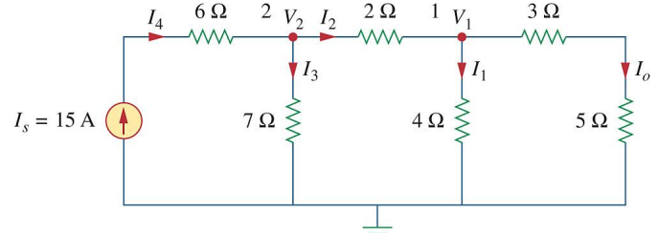
- $Assume I_{0} to be 1A$
- Work backwards through the problem
  - Using current division – $I_{0}=I_{2}\frac{4}{3+5+4}=1$
  - $I_{2}=3A$
  - ${I_{2}=I}_{4}\frac{7}{7+2+4||8}=I_{4}\frac{7}{11.67}$
  - $I_{4}=5A=I_{s}$
- Create a ratio for assumed values
  - $\frac{I_{0}}{I_{4}}=\frac{1}{5}$
- Use this ratio to calculate $I_{0}$
  - $\frac{1}{5}×I_{s}=I_{0}$
  - $I_{0}=3A$

Superposition
- The voltage and current flowing through each element is made up of the sum of the influence of each independent source
- Is a calculation of the contribution of each independent source separately
- Steps for calculations
  - Turn off all independent sources except for one, then calculate the output asked in the question
  - Repeat step one for each independent source
  - Add each of the values calculated in step one and two together
- Turning off sources
  - Voltage sources are replaced with a wire and leave all elements in series as part of the circuit
  - Independent current sources are replaced with an open circuit meaning that all elements in series are excluded
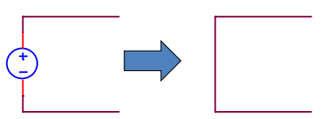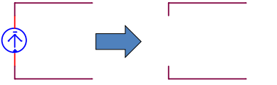

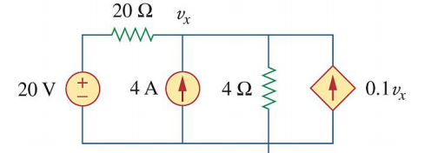
Example:

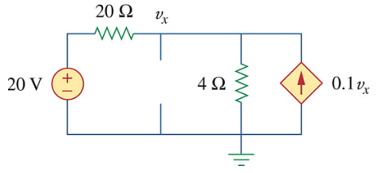
$$0=-0.1v_{x}+\frac{v_{x}}{4}+\frac{v_{x}-20}{20}$$
$$0=-2v_{x}+5v_{x}+v_{x}-20$$
$$20=4v_{x}$$
$$v_{x}=5V$$

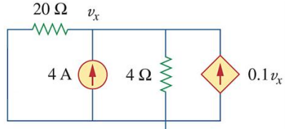
$$0=-4-0.1v_{x}+\frac{v_{x}}{20}+\frac{v_{x}}{4}$$
$$4=-2v_{x}+v_{x}+5v_{x}$$
$$4=4v_{x}$$
$$v_{x}=1V$$

$$v_{x}=4+1$$
$$v_{x}=5V$$

Source Transformations
- Involves the creation of an equivalent circuit with the same v and I values
- Voltage to Current
  - Change the resistor from series to parallel
  - Replace the voltage source with a current source with the current flowing I the direction that the positive terminal pointed
  - Use the equation $i_{s}=\frac{v}{R}$
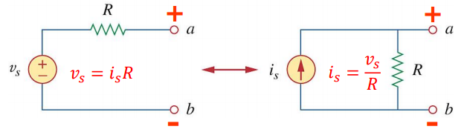
- Current to voltage
  - Change the resistor from parallel to series
  - Replace the current source with a voltage source
  - Use ohms law to calculate the new voltage value
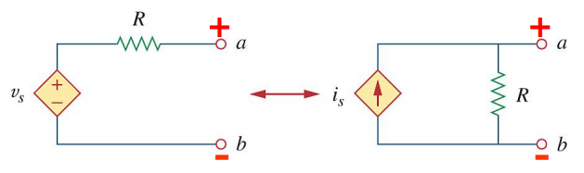

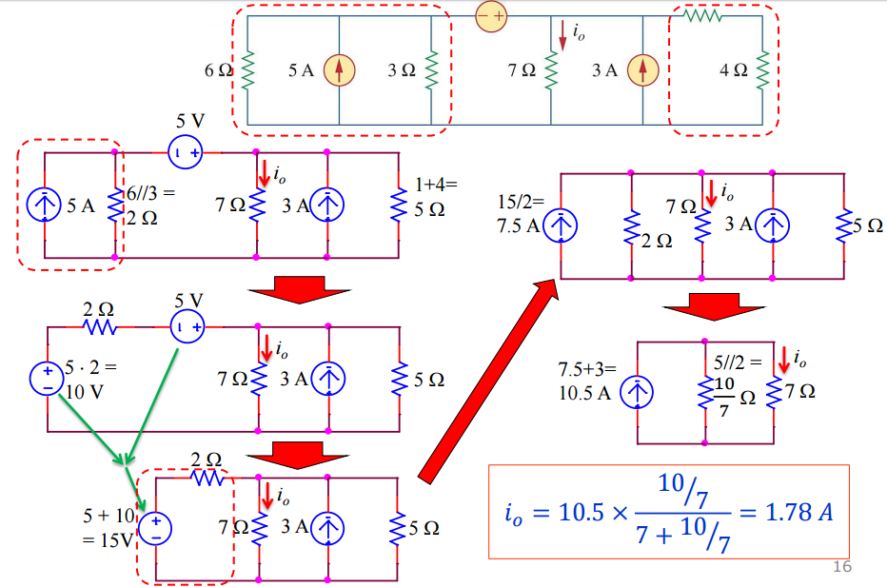

Thevenin’s theorem
- A two terminal circuit can be replaced with an equivalent circuit made up of a voltage source in series with a resistor
  - V_{th} is the open circuit voltage at the terminals
  - R_{th} is the equivalent resistance at the terminals when the independent sources are turned off
- Method 1 – circuit contains no dependant sources
  - Remove the load part of the circuit and draw in the open circuit V_{th}
  - Simplify/ use KCL and KVL to determine the value of V_{th}
  - Turn off all the independent sources and calculate the equivalent resistance - R_{th}
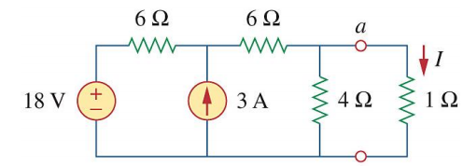
Example:

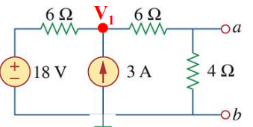
Step 1:

Step 2: Find V_{th}
$$0=-3+\frac{V_{1}-18}{6}+\frac{V_{1}}{10}$$
$$0=-90+5V_{1}-90+3V_{1}$$
$$V_{1}=22.5V$$
$$V_{ab}=V_{1}.\frac{4}{10}$$
$$V_{ab}=9V$$
$$∴V_{th}=9V$$
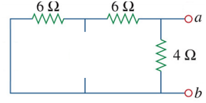
Step 3:

$$\left(6+6\right)||4=3Ω$$
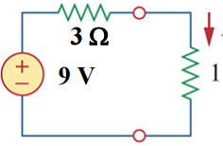
Final Circuit:

- Method 2 – With dependant sources
- Use the same method for determining V_{th}
- Dependant sources can’t be turned off thus they need to be kept
- Thus a Test source needs to be applied to the circuit either a
  - Voltage source if using node voltages is easier
  - Current source if mesh analysis would be easier
- Use the equation $R_{th}=\frac{v_{0}}{i_{0}}$
  - Where V₀ is either the 1V test source or the voltage across the 1A test current source
  - I₀ is either the 1A test source or the current flowing through the 1V test source
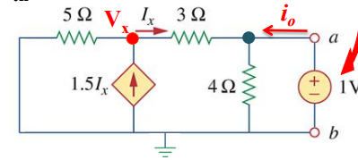
Example:

V_{x}:
$$0=\frac{V_{x}}{5}-1.5I_{x}+\frac{V_{x}-1}{3}$$
$$0=\frac{V_{x}}{5}-1.5\left(\frac{V_{x}-1}{3}\right)+\frac{V_{x}-1}{3}$$
$$0=3V_{x}-7.5V_{x}-7.5+5V_{x}-5$$
$$V_{x}=-5V$$
V₁:
$$0=-i_{0}+\frac{1-\left(-5\right)}{3}+\frac{1}{4}$$
$$i_{0}=2.25A$$
R_{th}:
$$R_{th}=\frac{v_{0}}{i_{0}}$$
$$R_{th}=\frac{1}{2.25}$$
$$R_{th}=0.4Ω$$

Norton’s Theorem
- Exactly the same as Thevenin’s theorem except resulting in a current source in parallel with a resistor
- Just the source transformation of Thevenin’s equivalent
- Use same steps as thevenin just short circuit a-b to find I_{N}
Example:
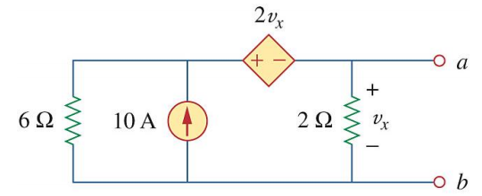
Step 1: Determine I_{N}
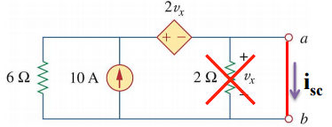
Thus V_{x} = 0 and the current flowing through 6Ω is 0A.
I_{sc} = 10A

Using Method 3: short circuit terminal a-b and do not zero any sources. R_{N}=V_{oc}/i_{sc}
V_{oc:} Use source transformation
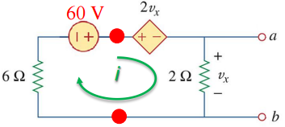
$$0=6\left(I\right)-60+2\left(2\right)I+2I$$
$$I=5V$$
$$∴V_{x}=V_{oc}=10V$$
I_{sc}:
Previously calculated to be 10A
$$R_{N}=\frac{V_{oc}}{I_{sc}}$$
$$R_{N}=\frac{10V}{10A}$$
$$R_{N}=1Ω$$

Maximum Power Transfer
- Applies when the whole circuit except for the load is replaced by the Thevenin equivalent
- Then the max power transferred to the load is:
  - $P=i^{2}\left(R_{L}\right)=\left(\frac{V_{th}}{R_{th}+R_{L}}\right)R_{L}$
  - Simplified to: $P=\frac{{V_{th}}^{2}}{4\left(R_{th}\right)}=\frac{{V_{L}}^{2}}{\left(R_{th}\right)}$
  - The load resistor must equal thevenins resistor for maximum power transfer to apply
- Method – use thevinins rule to simplify the circuit then just apply the equations

Operational Amplifiers
- Also called an op amp
- Behaves like a voltage controlled voltage source
- It is an active circuit element designed to perform mathematical operations such as addition, multiplication, differentiation etc.
- Made up of many different transistors and resistors inside the amplifier but not shown in the course
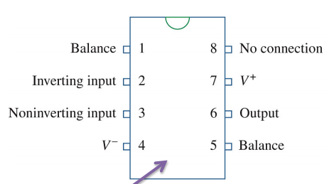
  - Connected up but the following pins

Non Ideal Op Amp
- Represented in the following way
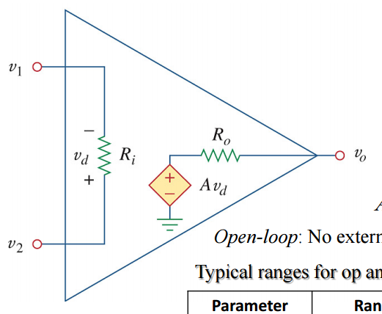
Equivalent Circuit is:
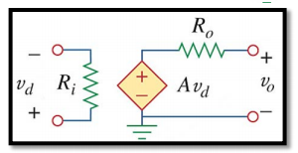
- Parameters are given as:
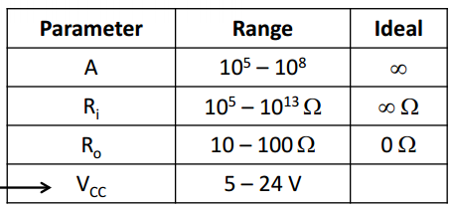
- Thus the output current is related to the voltage across R_{i}
  - But it is limited to |V_{cc}| the maximum voltage that can be supplied by the op-amp
- Method of calculating
  - Replace the op-amp symbol with the equivalent circuit (make sure that the positive and negative terminals are connected in the right places)
  - Simplify the circuit graphically and by using source transformations, inserting all the given information
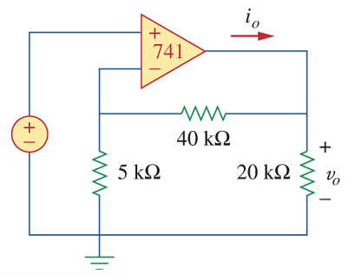
  - Solve as one would solve any other circuit problems
Example: Find V₀/V_{s} when A = 2 x 10⁵, R_{i} = 2 MΩ, R₀ = 50Ω.
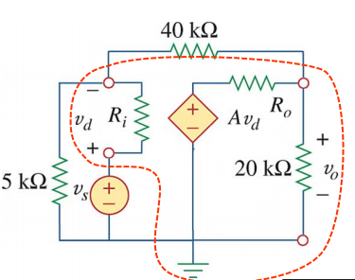
Step 1:

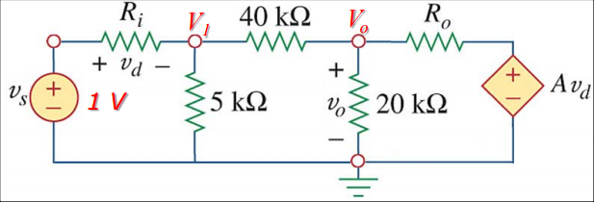
Step 2:

$$0=\frac{V_{1}}{5 000}+\frac{V_{1}-V_{s}}{2 000 000}+\frac{V_{1}-V_{0}}{40 000}$$
$$0=400V_{1}+V_{1}-V_{s}+50V_{1}-50V_{0}$$
$$V_{s}=451V_{1}-{50V}_{0}$$

$$0=\frac{V_{0}-(2×10^{5}){(V}_{s}-V_{1})}{50}+\frac{V_{0}}{20 000}+\frac{V_{0}-V_{1}}{40000}$$
$$0={800(V}_{0}-{200 000V}_{s}+200 000V_{1})+2V_{0}+V_{0}-V_{1}$$
$${160 000 000V}_{s}=803V_{0}+159 999 999V_{1}$$
$$451V_{s}=0.00226V_{0}+451V_{1}$$

$$∴450V_{s}=50.00226V_{0}$$
$$\frac{V_{0}}{V_{s}}=8.9996$$

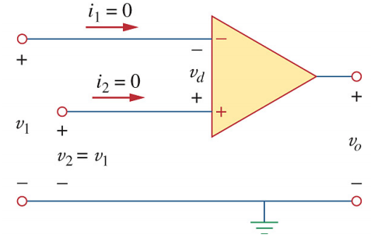
Ideal Op Amps
- Has the ideal characteristics as seen in the table above
- Since R_{i} = ∞
  - $i_{1}=i_{2}=0$
  - $v_{d}=v_{1}{-v}_{2}=0$
  - $v_{1}{=v}_{2}$

Example: Assume V_{s} = 1V and find V₀
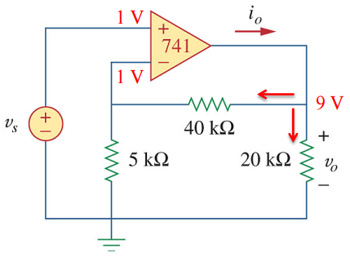
$$0=\frac{1}{5000}+\frac{1-v_{1}}{40000}$$
$$v_{1}=9V$$
$$∴V_{0}=9V$$

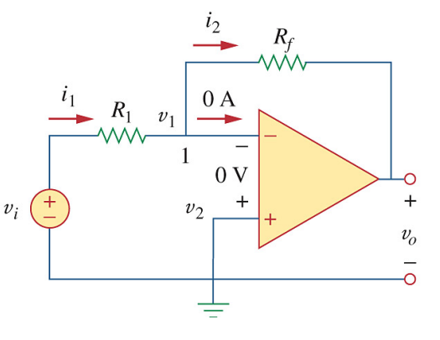
Inverting Amplifier
- This form of an op amp supplies similar voltage to the circuit just polarised
- Must have the following characteristics
  - An equivalent resistance in series with V_{i}
  - An equivalent resistance: Rf
  - An inverting input or output of 0V
- Thus the following equation applies:
$$v_{0}=-\frac{R_{f}}{R_{1}}v_{i}$$
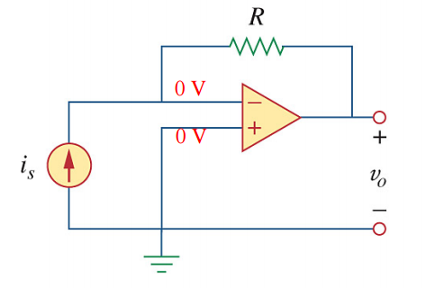
- Special case where
  - Current is supplied and not voltage
  - The resistance in series with the source = 0
  - Thus $v_{0}=-i_{s}R$

Non-Inverting Amplifier
- Designed to produce positive voltage gain
  - The voltage source is present in the positive inverting voltage terminal
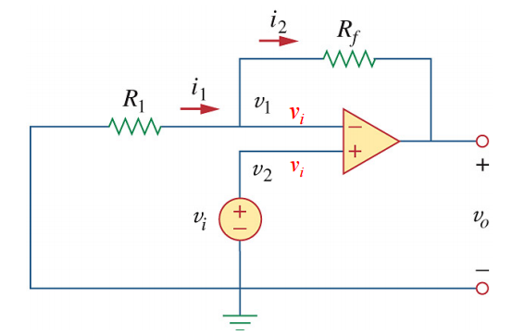
  - The two equivalent resistors are in the same place as the ones in inverting op amps
$$V_{0}=(1+\frac{R_{f}}{R_{1}})V_{0}$$

- Special case: Voltage follower
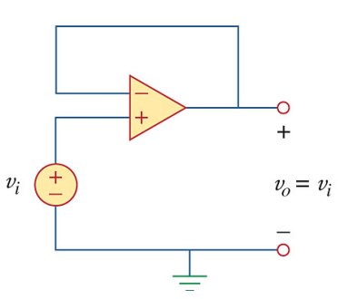
  - The R₁ branch is replaced with a short circuit
  - In this case the input = output $V_{0}= V_{i}$
  - Two uses
    - V_{i} can only source low current due to V_{cc} values whereas V₀ can source much higher ones
    - Can be used as a buffer to isolate one stage of a circuit from another

Summing Op Amps
- Combines multiple inputs to make one common weighted output
- Uses superposition theory to determine the contribution of each source to the output
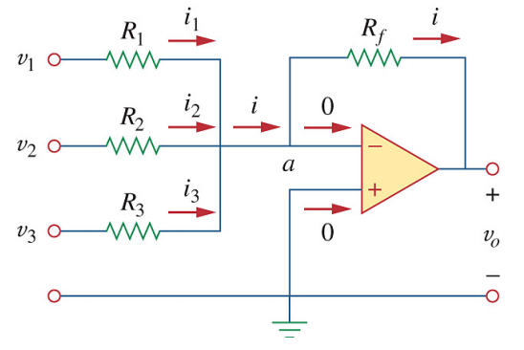
- Uses idea of superposition to make a common equation
  - $v_{0}=-\left(\frac{R_{f}}{R_{1}}v_{1}+\frac{R_{f}}{R_{2}}v_{2}+\frac{R_{f}}{R_{3}}v_{3}\right)$
Example:
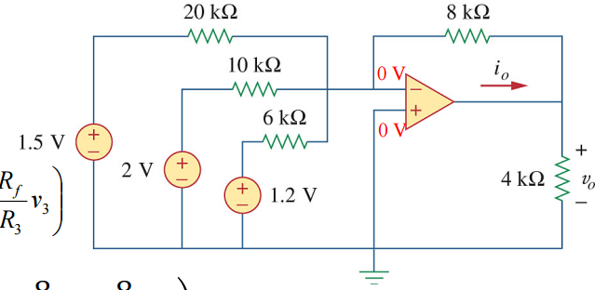
  - $v_{0}=-\left(\frac{8}{20}1.5+\frac{8}{10}2+\frac{8}{6}1.2\right)$
  - $v_{0}=-3.8V$

Difference op amp
- Combination of an inverting and a non-inverting op amp
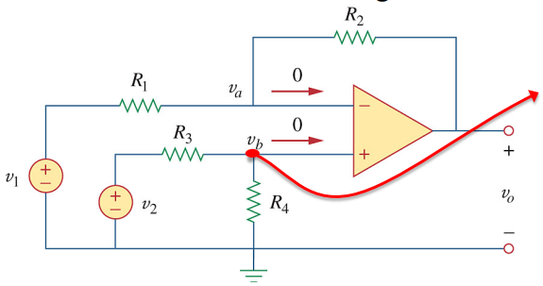
- Can be done using first principals
- Or use the equation:
  - $v_{0}=\frac{R_{2}(1+\frac{R_{1}}{R_{2}})}{R_{1}(1+\frac{R_{3}}{R_{4}})}v_{2}-\frac{R_{2}}{R_{1}}v_{1}$
Example:
Design a difference op amp with inputs v₁and v₂ such that v₀ = 3v₂ – 5v₁
$$\frac{R_{2}}{R_{1}}=5$$
$$R_{1}=1Ω R_{2}=5Ω$$
$$\frac{R_{2}\left(1+\frac{R_{1}}{R_{2}}\right)}{R_{1}\left(1+\frac{R_{3}}{R_{4}}\right)}=3$$
$$\frac{5(1+\frac{1}{5})}{1(1+\frac{R_{3}}{R_{4}})}=3$$
$$\frac{R_{3}}{R_{4}}=\frac{5(1+\frac{1}{5})}{3}-1$$
$$\frac{R_{3}}{R_{4}}=1$$
$$R_{3}=R_{4}=5Ω$$

Cascading Op amps
- Is the head to tail arrangements of many op amps
- Each op has an amplification value – the ration of v₀/v_{s}
- Generally just the value of the of the resistor ratios
- For cascaded ones use the equation
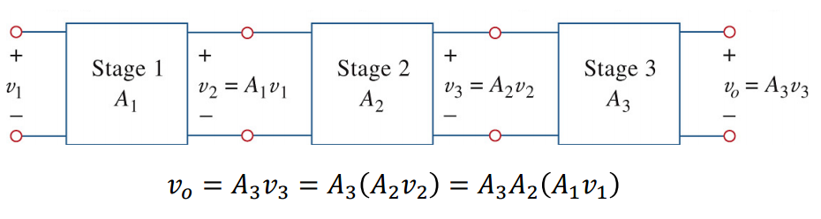

Chapter 6 – Conductors and Inductors

Capacitors
- Passive element designed to store energy in an electric field
- Consists of two conducting plates separated by an insulator
- Has a value of stored charge – capacitance
  - $C=\frac{εA}{d}$
  - A - Surface area of the metal plate
  - ε – permittivity of the dielectric
  - d – distance between the plates

- Capacitance - ratio of charge on one plate to the voltage difference between the two plates measured in Farads (F)
  - $c=\frac{q}{v}$
- Thus the following equations are used to calculate current and voltage as neither are constant across the capacitor
  - $i\left(t\right)=c\frac{d}{dt}v\left(t\right)$
    - I is positive if capacitor is charging and negative if discharging
  - $v\left(t\right)=\frac{1}{C}\int_{t_{0}}^{t}{i\left(t\right)dt}+v\left(t_{0}\right)$
- Energy and power
  - $w=\frac{1}{2}cv^{2}$
  - $p=vi=vC\frac{dv}{dt}$
- Capacitors are open circuits under DC conditions (capacitor is fully charged)
Example: The voltage source connected across a 10μF capacitor is given as $v\left(t\right)=5\sin\left(200t\right)V.$ Calculate i(t).
$$i=c\frac{dv}{dt}$$
$$=10×{10}^{-6}\frac{dv}{dt}\left(50\sin\left(2000t\right)\right)$$
$$=10×{10}^{-6}×50 ×2000×\cos\left(2000t\right)$$
$$=\cos\left(2000t\right)$$
- Capacitors in series are added like resistors in parallel
  - $\frac{1}{C_{eq}}=\frac{1}{c_{1}}+\frac{1}{c_{2}}+\frac{1}{c_{3}}$
  - Thus voltage division in series works like current division in parallel
  - $v_{1}=\frac{c_{2}}{c_{1}+c_{2}}v$
- Capacitors in parallel - act like resistors in series
  - $C_{eq}=c_{1}+c_{2}+c_{3}$
  - Thus current division works the same as voltage division in series
  - $I_{1}=\frac{c_{1}}{c_{1}+c_{2}}I$
Example: Find the equivalent capacitance
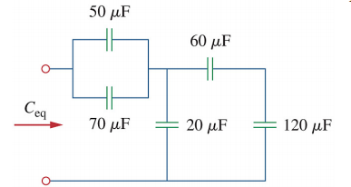
$$=\left(\left(60s120\right)+20\right)s\left(50+70\right)$$
$$=\left(40+20\right)s\left(120\right)$$
$$=40μF$$

Inductors
- Passive element designed to store energy in its magnetic field
- Equation for physical characteristics – measured in Henries (H)
  - $L=\frac{N^{2}μA}{l}$
    - l – length of the coil
    - μ – permeability
    - A – cross sectional area
    - N – number of turns
- Voltage and current equations
  - $v\left(t\right)=L\frac{d}{dt}i\left(t\right)$
  - $i\left(t\right)=\frac{1}{L}\int_{t_{0}}^{t}{v\left(t\right)dt}+i\left(t_{0}\right)$
  - $w=\frac{1}{2}Li^{2}$
  - $p=vi=iL\frac{di}{dt}$
  - Is a short circuit under DC conditions
- Inductors in series are added like resistors in series
  - $C_{eq}=c_{1}+c_{2}+c_{3}$
  - Thus voltage division in series works like voltage division in series
  - $v_{1}=\frac{c_{1}}{c_{1}+c_{2}}v$
- Inductors in parallel - act like resistors in parallel
  - $\frac{1}{C_{eq}}=\frac{1}{c_{1}}+\frac{1}{c_{2}}+\frac{1}{c_{3}}$
  - Thus current division works the same as current division in parallel
  - $I_{1}=\frac{c_{2}}{c_{1}+c_{2}}I$

Calculating problems with conductors and inductors
- the equations for the inductors/ capacitors given
  - Do not remove anything in the circuit
  - Use simplification and or voltage/current division to isolate the desired element
  - Use the above equations to calculate the answers
- No equations are given
  - Use DC conditions and solve the circuit without the other elements
Example using DC conditions:
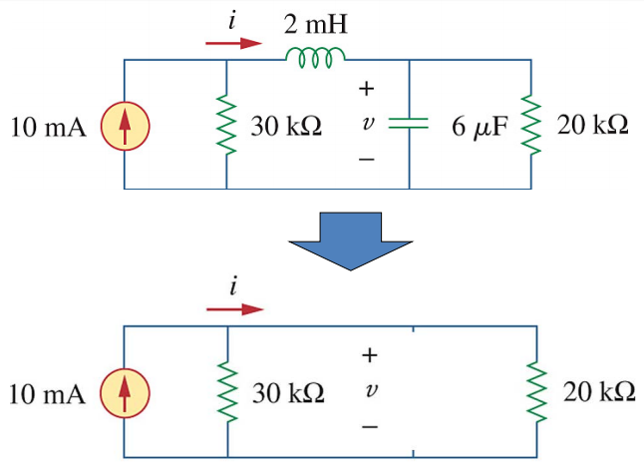
$$i=6mA$$
$$v=120V$$

Example using equations: If $i_{1}\left(t\right)=0.6e^{-2t}$ and i(0) = 1.4A. Find i₂(0), i₂(t), i(t), v₁(t), v₂(t) and v(t)
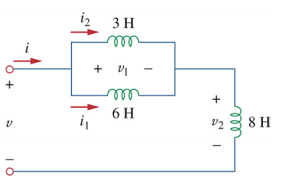
$$v\left(t\right)=L\frac{d}{dt}i\left(t\right)$$
$$v_{1}\left(t\right)=6\frac{d}{dt}0.6e^{-2t}$$
$$v_{1}\left(t\right)=6\left(-1.2\right)e^{-2t}$$
$$v_{1}\left(t\right)=-7.2e^{-2t}$$

$$i\left(t\right)=\frac{1}{L}\int_{t_{0}}^{t}{v\left(t\right)dt}+ i\left(t_{0}\right)$$
$$i_{2}\left(t\right)=\frac{1}{3}\int_{t_{0}}^{t}{-7.2e^{-2t}dt}+i\left(t_{0}\right) \\ i_{2}\left(t\right)=1.2e^{-2t}-1+i\left(t_{0}\right)$$

$$i_{1}+i_{2}=i$$
$$i_{1}\left(0\right)+i_{2}\left(0\right)=i\left(0\right)$$
$$0.6e^{-2\left(0\right)}+i_{2}\left(0\right)=1.4$$
$$i_{2}\left(0\right)=0.8A$$
$$i_{2}\left(t\right)=1.2e^{-2t}-1+0.8A$$
$$i_{2}\left(t\right)=1.2e^{-2t}-0.4A$$

$$i_{1}\left(t\right)=1.8e^{-2t}+1.4A$$
$$v_{2}\left(t\right)=8\frac{d}{dt}1.8e^{-2t}+1.4A$$
$$v_{2}\left(t\right)=-28.8e^{-2t}V$$

$$v_{1}+v_{2}=v$$
$$v=-36e^{-2t}V$$

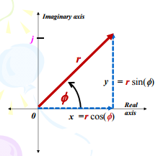
Chapter 9 – Sinusoids and phasors

Complex Numbers
- Complex numbers have both a real and an imaginary part
- Appear in 3 forms
  - Rectangular - $z=x+jy$
    - X – real part
    - Y – imaginary part
  - Polar - $z=r<φ$
    - Similar to polar co-ordinates
    - R –combination of the real and imaginary magnitudes
    - Φ – the angle between r and the positive real axis
      - Must lie in (-180,180)
  - Exponential - $z=re^{jφ}$
    - Seldom used
- Conversions between types
  - Rectangular to polar
    - $r=\sqrt{x^{2}+y^{2}}$
    - $φ=\tan^{-1}{\frac{y}{x}}$
      - Counter clockwise is positive
  - Polar to exponential
    - Use the same variables
- Complex number arithmetic
  - Addition – use rectangular form
    - $z=x_{1}+jy_{1}+x_{2}+jy_{2}$
    - $z=x_{1}+x_{2}+j(y_{1}+y_{2})$
  - Subtraction – same as addition
  - Multiplication – Use polar form
    - $z=r_{1}<φ×(r_{2}<φ)$
    - $z=r_{1}×r_{2}<(φ+φ$)
  - Division – same as multiplication
    - Subtract angles instead of add
  - Square root – use polar form
    - $\sqrt{z}=\sqrt{r_{1}}<\frac{φ}{2}$
  - Inverse – use polar form
    - $\frac{1}{z}=\frac{1}{r_{1}}<-φ$
  - Conjugate – use rectangular form
    - Change the sign before the imaginary part of the number

Sinusoids
- Signal in the form of a sine or cosine function
- $v1(t)=v_{m}\sin\left(ωt-φ\right)$
  - ω – the angular frequency in radians/s
  - v_{m} – the amplitude (maximum signal)
  - φ – the phase change of the function
- $T=\frac{2π}{ω}$
  - T – the period of the function (s)
- $f=\frac{1}{T}$
  - F – the frequency of the function (Hz)
- To simplify some equations the compound angle trig equations my need to be used
  - $\sin\left(a±b\right)=\sin\left(a\right)cos\left(b\right)±\cos\left(a\right)\sin\left(b\right)$
  - $\cos\left(a±b\right)=\cos\left(a\right)\cos\left(b\right)∓\sin\left(a\right)\sin\left(b\right)$
- All sinusoids must be converted into the form: $v1(t)=v_{m}\cos\left(ωt±φ\right)$
  - To do this use the following graph form
-sin(ωt+75) = cos(ωt+165)
-sin(ωt)
-sin(ωt-60) = cos(ωt+30)
-cos(ωt)
sin(ωt)

cos(ωt)

Example: Transform $v=27\sin\left(3t-60\right)$into standard form
$$v=-27\cos\left(3t+30\right)$$
$$v=27\cos\left(3t-150\right)$$
- Leading and lagging
  - Considering two vectors:
  - Use the smallest angle between the two
  - When moving clockwise from one vector to the other across the smallest vector:
    - The starting vector is lagging
    - The second is leading
- Converting sinusoids to into phasors
  - Change the phasor into standard form
  - $v1(t)=v_{m}\cos\left(ωt±φ\right)→v_{m}<φ$
  - $\frac{dv}{dt}=jωV$
  - $\int{v dt=\frac{V}{jω}}$

Impedance and Admittance
- Admittance – the equivalent of resistance for AC circuits
  - Represented by Z and measured in Ohms
  - Same as resistance for resistors
  - All equations such as voltage division, wye to delta equations and series/parallel equations are exactly the same as the resistance ones
  - For inductors
    - $Z=jωL$
    - Using CIVIL – voltage leads current
  - For capacitors
    - $z=\frac{1}{jwC}$
    - Using CIVIL – current leads voltage
- Impedance – equivalent of conductance for AC circuits
  - Represented by Y and measured in Siemens
  - Simply the inverse of admittance
- When working with circuits of multiple types of passive elements and AC current
  - Change all capacitance and inductance into admittance
  - Convert all sources into phasors
  - Look to find Z_{eq} – likely needed for the problem
  - Treat the equation as one would a normal DC circuit
Example:

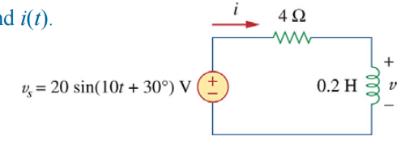
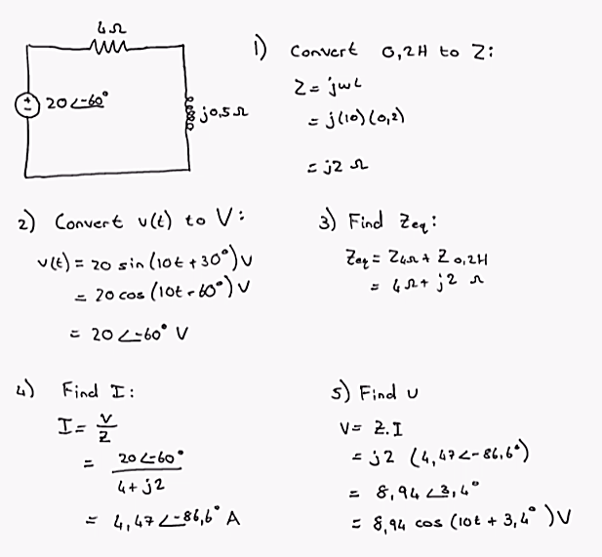
Example 2: Find Z
